Smart Cents Weekly
Modern Financial Education for Young Investors
Week 4 • August 24, 2025

Contents: Welcome | Market Analysis | Our Picks | Educational Insights | Using Tools | Thank you
Powered by Meridian Research

Welcome 👋

This is MeridianAlgo’s fourth financial newsletter. If you’re returning from our previous editions, thank you for coming back; we dedicate ourselves to educating young investors and supporting our community in any way we can, which means a lot to us. If you're new here, welcome! In this document, you'll find MeridianAlgo's insights on the US stock market, designed to boost your financial knowledge and investment skills for a brighter future. Our analysis is powered by proprietary machine learning algorithms, which you can see at the bottom of this document, along with our preferred charting platform: TradingView. We hope the market insights shared here, covering the past week and upcoming weeks, will help you better understand how markets really work and what happens behind the scenes.

What's Happening with the Market❓
Looking Overall
The S&P 500 gained about 1.4% this week, climbing from roughly 6,355 points to a close of 6,453.1 points on August 22, as shown in the finance card above. It hit an intraday high of 6,465 during trading. This rise persisted despite mixed economic signals, including stronger-than-expected retail sales data, which eased recession fears but raised concerns about delayed Federal Reserve rate cuts. Tech giants like NVIDIA and Microsoft drove gains, supported by solid earnings reports. The backdrop remains cautiously optimistic: volatility is low, investor confidence is steady, and economic momentum continues. However, inflation concerns linger, and disciplined investing remains key, especially with potential rate cut expectations for September.
Current Market Snapshot
The market maintained its upward trend, with the S&P 500 and other major indices near all-time highs. Investor confidence is high, with buying interest sustaining momentum after minor dips. Large-cap tech continues to lead, but broader sector participation, including consumer and financial stocks, supports a balanced market. This suggests healthy demand without signs of overextension.
Volatility Check
The VIX fell from around 14.5 to 14.22 by August 22, reflecting low market fear and stable trading conditions, as noted in the finance card above. Social media commentary highlights short covering after small pullbacks, keeping volatility subdued. Low VIX levels typically align with gradual gains, but investors should stay vigilant for potential complacency-driven corrections.

Our Picks and Historical Data ⛏️

Last week, we provided you with research on the following stock picks picks for the following week to consider for your portfolios along with research. Now, looking at them, you can see how our predictions unfolded:
Stocks | % change (since previous Friday)
AAPL | +2.21%
MSFT | +2.62%
META | -3.92%
NFLX | -2.71%
UBER | +4.66%
JPM | +1.64%
SBUX | -2.55%
All predictions are uncertain. Use these insights as part of your broader research process.

What do you think? Amazing returns? Or still have to improve? Well not to worry cause our coders are here. Using our in-built program Ara AI we improve each time so these predictions WONT lose they will just keep getting better and better as you go on. But these results are already amazing. If you invested $1000 split seven ways last week would yeild Last week: $1,000 investment split equally would make $2.78 profit. If weekly performance continued: $157 yearly profit on $1,000.

All predictions are uncertain. Use these insights as part of your broader research process.

Money Basics 🧗
Recap
Last time, we covered budgeting which frees up money to invest and helps you stay consistent with your financial goals. With cash to work, the next step is to understand how much risk you are willing to take on for potential benefits.
Risk vs Reward
One of the factors to consider when investing is the gains and losses we can incur.
- Low Risk, Low Return: Savings accounts and government bonds keep your money safe but grow slowly.
- Moderate Risk, Moderate Return: Index funds and ETFs offer diversification and steady long-term growth.
- High Risk, High Return: Individual stocks, crypto, or startups can deliver big gains but also big losses.
- Risk-to-Reward Ratio: Compare potential upside to potential downside. For example, if you risk $100 with the chance to gain $300, that’s a 1:3 ratio generally attractive. If you risk $100 for only $50 upside, that’s 2:1 against you usually not worth it.
- Personal Risk Tolerance: Your age, goals, and comfort level determine how much risk you can realistically handle. The right balance isn’t about chasing the highest return, rather it’s about aligning investments with your goals and peace of mind.
Pro Tip: A smart investor looks for opportunities where the potential reward outweighs the potential risk and avoids bets where the math doesn’t add up.

Let’s Learn 🤔

🛠️ Python Utilities

We recently updated our python resources repository for YOU so even beginners can learn about open-source financial tools.
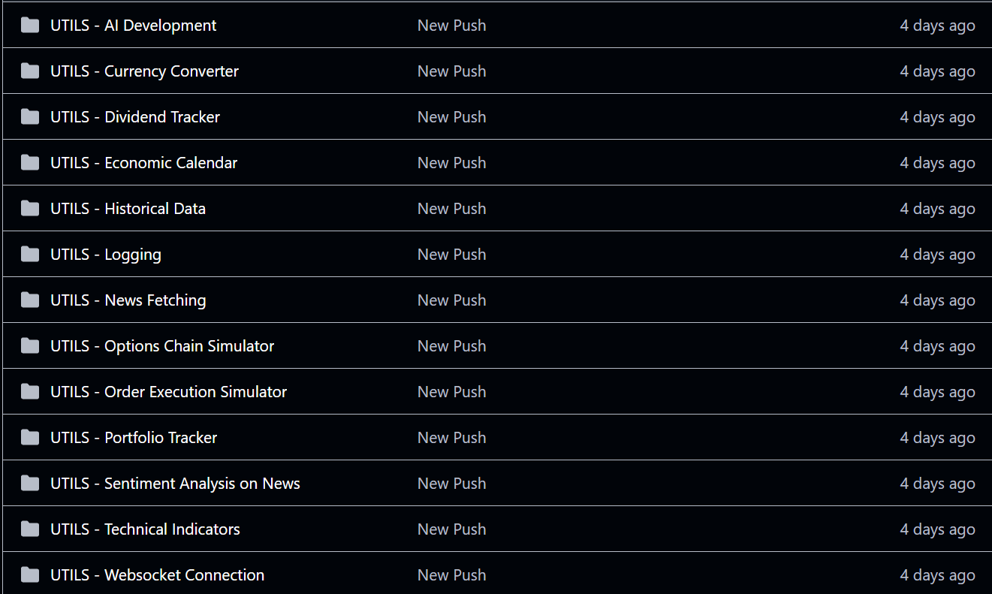
Check it out here at https://github.com/MeridianAlgo/Utils

Thank you for reading Smart Cents Weekly
Continue your financial education journey with us next week.

Some quick financial legal stuff below ⬇️
The information provided herein is for informational and educational purposes only and does not constitute financial, investment, or trading advice. MeridianAlgo and the authors who wrote this document cannot be constituted as licensed financial advisors. We simply provide actionable insights to the world, increasing literacy and helping people. Always do your research and consult with a qualified financial advisor before making any investment decisions. Past performance is not indicative of future results. Investing involves risk, including the possible loss of principal.

Shameless plugs 😭
Website: http://meridianalgo.org
Github: https://github.com/MeridianAlgo
Tradingview: https://www.tradingview.com/
Donations: https://hcb.hackclub.com/donate

MeridianAlgo is a 501(c)(3) nonprofit with fiscal sponsorship from the Hack Club Foundation. We are dedicated to making financial literacy more accessible to youth. Since we don't make a profit or have a source of income, we rely on donations and grants from our local community to fund our operations and host events for many to enjoy. Whether it be at a library, event hall, or even online, we aim to ensure our generation can build wealth efficiently and smartly. Thank you.

